PUBLIC CONSECRATION PRAYER TO DIVINE WILL

Oh Omnipotent and Eternal God, Father, Son and Holy Spirit, we the littlest of Your beloved children from Your Emerald Isle –
come before Your Supreme Majesty on this Feast of the Divine Will in the Year 2020.

We come, Father, to offer you – with one heart and soul – our public and permanent FIAT
in the hands and through the Immaculate Heart of our dearest Mother and Model of living in the Divine Will…

Through Her and with Her, we, too, DECLARE before Heaven, Earth and Hell:

FIAT MIHI SECUNDUM VERBUM TUUM! - BE IT DONE UNTO ME ACCORDING TO YOUR WORD

Oh, Holy God, Creator, Lord and King of the Universe, we come today – enclosed in the arms of our dearest Mother –
TO OPEN THE DOOR for Jesus’ return in Glory!

Yes! We ARE the least important of your littlest children, but we WANT to change History!

The time has come for the Spirit and the Bride to proclaim, in unison:

MARANATHA! COME, LORD JESUS!

The Holy Spirit and His most holy Bride – our dearest Mother –
declare that the time has come for the NEW ERA of Divine Holiness to begin.
We, though painfully aware of: our unworthiness, our poverty, and our absolute nothingness –
are ALSO aware that we represent the Bride on Earth.

We represent THAT part of the Church that is aware of the need to respond to the call of our Returning Saviour,
Lord and King, as He says to us in the Song of Songs 5:2:

“I hear my beloved knocking… (He calls out…)
Open up to me, my sister, my love, my dove, my perfect one…
My beloved thrust his hand through the hole in the door; I trembled to the core of my being”.

Oh my Lord Jesus, representing Your Bride on earth, we declare in union with our Blessed Mother – Your Bride in Heaven:
- Yes! Jesus, come! We call you with all of our hearts!
- Come among us again! Reign among us as You do in Heaven!
- We want the Triumph of the Two Hearts of Jesus and Mary!
- Divine Shepherd, return to your scattered sheep!
- Collect the little lambs who have strayed in the mountains –
- Heal the wounded ones, and Yes! Raise those spiritually dead!
- Show the world again WHO YOU ARE Holiest One!
- Jesus, Holiest One, you also said in Revelation 3:20:

“Look, I am standing at the door, knocking.
If one of you HEARS ME calling AND OPENS THE DOOR
I will come in and share his meal, side by side with him”.

Lord, we open our hearts to you! Come and reign through us!
- We lay down our human wills at Your Divine Feet. Come, live and work in us and through us.
- We put our families at Your Feet: Shepherd them to Eternal Life.
- We lay down our Nation at Your Feet: Reign as King among us!
- We lay down the whole Earth and all humanity at Your Feet: King of Heaven and Earth – PANTOCRATOR – RULE OVER US!
- We ARE yours by the fact of Your Fiats of Creation and Redemption. Now let the Fiat of Sanctification take its rule.
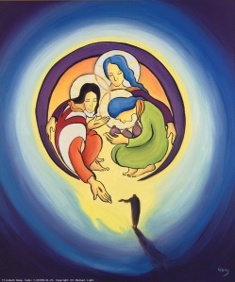
- So, come oh Supreme Volition to reign upon the Earth. Invest all generations. Win and conquer all, and do not delay any longer. AMEN.

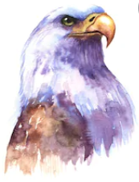
Signature: _ _ _ _ _ _ _ _ _ _ _ _ _ _ _ _ _ _ _

Date: _ _ _ _ _ _ _ _ _ _ _ _ _ _

